Contents
Chapter Page
Glossary 3
1. Ground Model and Parameters 4
1.1. Ground Model for the Ground Improvement 4
1.2. Geotechnical Parameters 25
2. References 31
Appendix A. Plan and Sections 33
Appendix B. Geological Information, Data, Plans and Sections 34
B.1. Geotechnical Information / Data 34
B.2. Geological Plans 38
B.3. Geological Sections 39

Tables
Table 3-1 – Engineering Geological Units 4
Table 3-2 – EW0414 Superficial Soil Domains 5
Table 3-3 – EW0414 Top of Crag Bedrock Soil Domains 5
Table 3-4 – EW0414 Design Ground Models (DGM) – Justification 6
Table 3-5 – Stepped top of Crag and Reference DGMs 11
Table 3-6 – EW0412 DGM reference drawings 12
Table 3-7 – EW0414-DGM_11 – South West Corner of MCA COW 14
Table 3-8 – EW0414-DGM_12A – Alluvium & Peat Overlying Deepest Crag (SSD_3A) 15
Table 3-9 – EW0414-DGM_12B – Made Ground Overlying Deepest Crag (SSD_2) 16
Table 3-10 – EW0414-DGM_13 – Alluvium & Peat Overlying Deepest Crag Group (SSD_3) 17
Table 3-11 – EW0414-DGM_14A – North West Corner 18
Table 3-12 – EW0414-DGM_14B – North West Corner 19
Table 3-13 – EW0414-DGM_15 – Deep Crag Group adjacent to the Northern Mound 20
Table 3-14 – EW0414-DGM_16 – Variable and Deep Crag Group underlying the Northern Mound 21
Table 3-15 – EW0414-DGM_17A – Southern Access Road SSD_1 22
Table 3-16 – EW0414-DGM_17B – Southern Access Road SSD_1A 23
Table 3-17 – EW0414-DGM_17C – Southern Access Road SSD_3A 24
Table 3-18 - Design Geotechnical Parameters at EW0414 Ground Improvement Works for SD3 Group 26
Table 3-19 – Design Geotechnical Parameters at EW0414 Ground Improvement Works for SD1, SD2, SD4 and SD5 27

Figures
Figure 3-1 – DGM and section location plan 6
Figure 3-2 – Simplified EW0414-P_03 Top of Undifferentiated Alluvium & Peat Plan 10
Figure 3-3 – Simplified EW0414-P_04 Top of Crag Group Plan 11
Figure 3-4 – Simplified EW0414-EGLS_01 Showing stepped top of Crag Group 11

Appendix Tables
Table B-1 Available geotechnical reports 34
Table B-2 Available geotechnical drawings 34
Table B-3 Available geotechnical models 35
Table B-4 Available geotechnical databases 35
Table B-5 Data digitized 36
Table B-6 Data excluded 36

Ground Model and Parameters

Ground Model for the Ground Improvement

Geotechnical Information / Data

Included Information
The sources of information considered in developing the ground models and parameters are presented in Appendix B.
The information presented in Table B5 was digitized specifically for the EW0412 & EW0414 packages to develop the ground model at the SZB Southern Access Road, where there was no coverage from the TEGG’s Geological Ground Model (GGM) (5213850-SNC-MR-XX-M3DM-G-000001).

Design Ground Models (DGM)
Design Ground Models (DGMs) have been generated considering the engineering behaviour of the encountered engineering geological units and their associated geotechnical parameters.
Superficial and bedrock soil domains have been identified in order to spatially constrain areas of similar engineering geological units and stratigraphy.
Boreholes within 10 m of the design element and DGM area of applicability are typically considered in the DGM development, however boreholes further away are also considered where there is limited data and / or to account for significant geological features represented in the available data.

Engineering Geology Units
Engineering geological units relevant to the EW0414 package are grouped in the MCA based on the distinctive lithostratigraphical divisions and are summarized in Table 3-1.
Table 3-1 – Engineering Geological Units
Strata | Description
Topsoil | Silty medium Sand.
Made Ground | Gravelly fine to coarse SAND (Assumed re-worked Crag).
Superficial Deposits  Alluvial Deposits &Peat (Undifferentiated) | Slightly gravelly clayey fine to medium SAND.  Very soft to firm silty CLAY.  Spongy to firm brown pseudo fibrous, fibrous or amorphous PEAT with plant remains. Variable in composition.
Crag Group Deposits (Undifferentiated) | Norwich Crag Group (NCG C1) – Uniform fine SAND. Can have clay bands, shells, flint pebbles.  Red Crag (RCG C2) – Dense to very dense shelly SAND. Can have clay bands & local cementing.  Red Crag (RCG C3) – Very dense fine sand with shells. Can have clay bands.
Note:
  - Descriptions summarised from Table 4-2 and 4-3 of Geotechnical Design Report (Ground Conditions and Geotechnical Parameters) SZC-EW0400-ATK-XX-000-XXXXXX-REP-CIV-000002 [1].
Topsoil is excluded as it is assumed stripped during early profiling and platforming (EW0415).
Harwich Formation, Lambeth Group, Lista Formation, and Chalk Group are subsequently proven underlying the Crag Group but are not considered for the purpose of design in this work package, as these layers are located at depths greater than the potentially applicable base of Deep Soil Mixing.

Geological Features of Note

Paleo Erosion Channel Feature
A key feature of the top of Crag Group is a deeply incised paleo erosion channel feature trending east to west though the Sizewell C MCA. The paleo erosion feature is infilled with highly compressible Alluvial Clay and Peat. The paleo erosion channel feature is characterised by the sloping sides from 1.00 m AOD to -6.00 m AOD and an undulating channel base below -6.00 m AOD that typically undulates between -8.00 m AOD and -11.0 m AOD. Near the EW0414 package footprint GI has proven top of Crag Group as deep as -12.18 m AOD (MPM 2019_10). The paleo erosion channel feature geometry has been considered in developing the Top of Crag Group Bedrock Soil Domaining (presented in Table 3-3).

Variable Made Ground
Made Ground is variable and is anticipated to partially underly the EW0414 package. The Made Ground of the MCA is typically a Gravelly fine to coarse SAND however it may contain inclusions of construction waste like concrete blocks.

Sand Pits
Historical Ordnance Survey mapping published in 1905 [2] shows a number of sand pits located though the Sizewell area. The sand pits are cut into the top of Crag Group, resulting in deep top of Crag Group backfilled with Made Ground. One of the mapped sand pits intersects the Southern Access Road and aligns with anomalously deep Made Ground encountered CHB 2009_10 (Made Ground to 7.15 m BGL). The location of sand pits is show in in EW0414-P_04.

Northern Mound
A key feature of the north of the MCA is the Northern Mound, Made Ground spoil piles understood to be reworked Crag Group sands from the construction of Sizewell B. They are up to 12 m in height are associated with significant overburden and surcharge on the underlying Alluvium and Peat. The overburden area of the Northern Mound and Bent Hills is defined in the Superficial Soil Domaining. The Northern Mound is shown as a topographical high in EW0414-P_01 Topography Plan.

Soil Domaining
The Superficial Soil Domains and Top of Crag Group Soil Domains relevant to the EW0414 package are presented in Table 3-2 and Table 3-3 respectively and shown in plan and section in Appendix B EW0414-P_02 and EW0414-P_04 respectively.
Table 3-2 – EW0414 Superficial Soil Domains
Domain | Domain Description
SSD_1 | Made Ground overlying Superficial Deposits
SSD_1A | Made Ground overlying Superficial Deposits (Low Certainty)
SSD_2 | Made Ground overlying Crag Group
SSD_3 | Alluvium & Peat Superficial Deposits from Ground Level
SSD_3A | Alluvium & Peat Superficial Deposits from Ground Level (Low Certainty)
SSD_3B | Alluvium & Peat Superficial Deposits with Variable Made Ground
SSD_4 | Made Ground Overburden (0 - 8m)
SSD_5 | Made Ground Overburden (>8m)
Table 3-3 – EW0414 Top of Crag Bedrock Soil Domains
Domain | Description | Typical Elevation  (mAOD)
Shallow Crag Group | Exploratory investigation indicates shallow top of Crag Group associated with the south of the MCA. | Greater than 1.00
Variable Crag Group | Exploratory investigation indicates variable top of Crag Group. Associated with the edges of the east-west trending paleo-erosion channel feature and associated locally incised paleo-erosion channels features. | 1.00 to -6.00
Deep Crag Group | Exploratory investigation shows deep top of Crag Group associated with the base of the east-west trending paleo-erosion channel feature. | -6.00 to -11.00  Typically less than - 8.00

DGM Summary

DGM Justification
Design Ground Models (DGMs) have been produced for analysis to describe the ground models at discrete locations deemed critical for design (termed DGM_# where # is model number).
Where data gaps have been identified and there is uncertainty in key geological boundaries, a cautious estimate of geological boundary has been selected as design level. Additionally, at selected locations confirmatory construction phase GI has been specified in 5213850-SNC-XX-XX-TSPC-G-000590. the lack of ground investigation and uncertainty in geological boundaries poses a risk.
The DGM locations are presented in Figure 3-1, they are summarised in Table 3-5, and critical DGM justification is presented in Table 3-4. The critical DGMs are presented in Section 3.1.2.5.

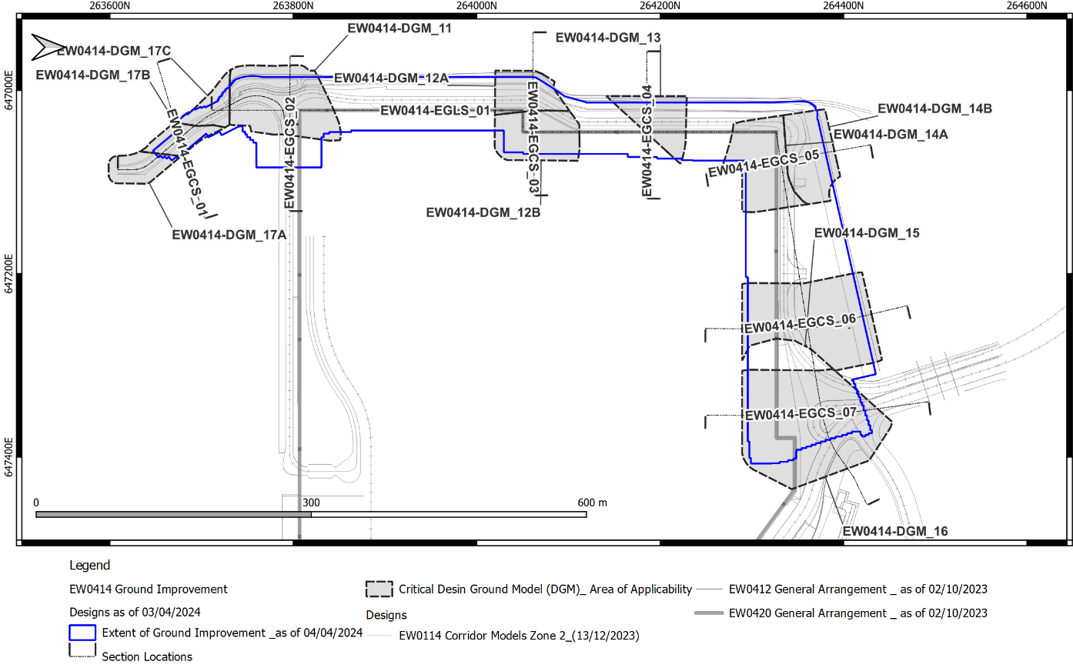
Figure 3-1 – DGM and section location plan
Table 3-4 – EW0414 Design Ground Models (DGM) – Justification
DGM Ref. | Description
EW0414-DGM_11 | Description South West Corner of MCA COW Undifferentiated Alluvium & Peat overlying Crag Group  Area of Application Project Chainage North and West Ground Improvement 034 – 100, SSD_3A.  Soil Domains SSD_3A, Variable Crag Group.  Reference Table 3-7 – EW0414-DGM_11 – South West Corner of MCA COW EW0414-EGLS_01 – North and West Ground Improvement Engineering Geological Long Section EW0414-EGCS_01 - EW0414-DGM_11 Engineering Geological Cross Section  Data Gaps Significant data gap (low density of boreholes) present in SSD_3A. Only three exploratory holes within DGM.
EW0414-DGM_12A | Description Alluvium & Peat Overlying Deepest Crag (SSD_3A) Maximum thickness of Alluvium & Peat to be treated associated with deepest treatment level. Differentiated from EW0414_DGM_12B by the absence of Made Ground.  Area of Application Project Chainage North and West Ground Improvement 275-307, SSD_3A.  Soil Domains SSD_3A, Deep Crag Group.  Reference Table 3-8 – EW0414-DGM_12A – Alluvium & Peat Overlying Deepest Crag (SSD_3A) EW0414-EGLS_01 – North and West Ground Improvement Engineering Geological Long Section EW0414-EGCS_02 - EW0414-DGM_12 Engineering Geological Cross Section  Data Gaps Significant data gap (low density of boreholes) present in SSD_3A. Exact location of transition from SSD_3A to SSD_1 is uncertain due to data gap in SSD_3A.
EW0414-DGM_12B | Description Made Ground Overlying Deepest Crag (SSD_2) Maximum thickness Made Ground overlying Alluvium & Peat to be treated associated with deepest treatment level. Differentiated from EW0414_DGM_12A by the presence of Made Ground.  Area of Application Project Chainage North and West Ground Improvement 308-391, SSD_1.  Soil Domains SSD_1, Deep Crag Group  Reference Table 3-9 – EW0414-DGM_12B – Made Ground Overlying Deepest Crag (SSD_2) EW0414-EGLS_01 – North and West Ground Improvement Engineering Geological Long Section EW0414-EGCS_02 - EW0414-DGM_12 Engineering Geological Cross Section  Data Gaps SSD_1 has a comparatively high density of boreholes compared with SSD_3A. Exact location of transition from SSD_1 to SSD_3A is uncertain due to data gap in SSD_3A.
EW0414-DGM_13 | Description Alluvium & Peat Overlying Deepest Crag Group (SSD_3) Maximum thickness of Alluvium & Peat to be treated associated with deepest treatment level.  Area of Application Project Chainage North and West Ground Improvement 464-507.  Soil Domains SSD_3, Deep Crag Group  Reference Table 3-10 – EW0414-DGM_13 – Alluvium & Peat Overlying Deepest Crag Group (SSD_3) EW0414-EGLS_01 – North and West Ground Improvement Engineering Geological Long Section EW0414-EGCS_03 - EW0414-DGM_13 Engineering Geological Cross Section  Data Gaps Low density of boreholes present in SSD_3.
EW0414-DGM_14A | Description Deep Crag Group in North West Corner  Area of Application Project Chainage North and West Ground Improvement 558-690.  Soil Domains SSD_3, SSD_3A, Deep Crag Group  Reference Table 3-11 – EW0414-DGM_14A – North West Corner EW0414-EGLS_01 – North and West Ground Improvement Engineering Geological Long Section EW0414-EGCS_04 - EW0414-DGM_14 Engineering Geological Cross Section  Data Gaps Low density of boreholes present in SSD_3 and SSD_3A.
EW0414-DGM_14B | Description Variable to Deep Crag Group in North West Corner  Area of Application Project Chainage North and West Ground Improvement 558-690.  Soil Domains SSD_3, SSD_3A, Variable to Deep Crag Group  Reference Table 3-12 – EW0414-DGM_14B – North West Corner EW0414-EGLS_01 – North and West Ground Improvement Engineering Geological Long Section EW0414-EGCS_04 - EW0414-DGM_14 Engineering Geological Cross Section  Data Gaps Low density of boreholes present in SSD_3 and SSD_3A.
EW0414-DGM_15 | Description Deep Crag Group adjacent to the Northern Mound  Area of Application Project Chainage North and West Ground Improvement 771-831.  Soil Domains SSD_1, SSD_3, SSD_3B. Deep Crag Group.  Reference Table 3-13 – EW0414-DGM_15 – Deep Crag Group adjacent to the Northern Mound EW0414-EGLS_01 – North and West Ground Improvement Engineering Geological Long Section EW0414-EGCS_05 - EW0414-DGM_15 Engineering Geological Cross Section  Data Gaps Low density of boreholes present in SSD_3.
EW0414-DGM_16 | Description Variable and Deep Crag Group underlying the Northern Mound  Area of Application Project Chainage North and West Ground Improvement 866-974.  Soil Domains SSD_1, SSD_4 and SSD_5. Variable Crag Group, Deep Crag Group.  Reference Table 3-14 – EW0414-DGM_16 – Variable and Deep Crag Group underlying the Northern Mound EW0414-EGLS_01 – North and West Ground Improvement Engineering Geological Long Section EW0414-EGCS_06 - EW0414-DGM_16 Engineering Geological Cross Section  Data Gaps Comparatively high density of boreholes within all soil domains
EW0414-DGM_17A | Description Southern Access Road SSD_2 - Made Ground overlying Crag Group  Area of Application Project Chainage Southern Access Road 000-052.  Soil Domains SSD_2, Variable Crag Group.  Reference Table 3-15 – EW0414-DGM_17A – Southern Access Road SSD_1 EW0414-EGLS_02 - Southern Access Road Engineering Geological Long Section EW0414-EGCS_07 - EW0414-DGM_17 Engineering Geological Cross Section  Data Gaps Low density of boreholes in this area. Several historical boreholes located in area and used for reference. This data gap results in significant uncertainty in the ground model at this location.
EW0414-DGM_17B | Description Southern Access Road SSD_1A - Made Ground overlying Alluvium & Peat overlying Crag Group  Area of Application Project Chainage Southern Access Road 052-101  Soil Domains SSD_1A, Variable Crag Group.  Reference Table 3-16 – EW0414-DGM_17B – Southern Access Road SSD_1A EW0414-EGLS_02 - Southern Access Road Engineering Geological Long Section EW0414-EGCS_07 - EW0414-DGM_17 Engineering Geological Cross Section  Data Gaps Low density of boreholes in this area. Several historical boreholes located in area and used for reference. This data gap results in significant uncertainty in the ground model at this location.
EW0414-DGM_17C | Description Southern Access Road SSD_3A - Alluvium & Peat overlying Crag Group  Area of Application Project Chainage Southern Access Road 101-144  Soil Domains SSD_3A, Variable Crag Group.  Reference Table 3-17 – EW0414-DGM_17C – Southern Access Road SSD_3A EW0414-EGLS_02 - Southern Access Road Engineering Geological Long Section EW0414-EGCS_07 - EW0414-DGM_17 Engineering Geological Cross Section  Data Gaps Low density of boreholes in this area. Several historical boreholes located in area and used for reference. This data gap results in significant uncertainty in the ground model at this location.

Stepping of Key Geological Surfaces
Between the critical DGMs the key geological surfaces have been stepped to provide design levels across the footprint of the ground improvement works.
The top of Undifferentiated Alluvium & Peat has been stepped at cautious estimate of (higher than) critical proven points in local GI. This stepping is present in Engineering Geological Sections and in EW0414-P_03 Top of Undifferentiated Alluvium & Peat Elevation Plan and Figure 3-2. This level also represents the base of Made Ground where there is Made Ground (SSD_1, SSD_1A, SSD_2, SSD_3B, SSD_4 and SSD_5), or ground surface (GS) elsewhere (SSD_3, SSD_3A).
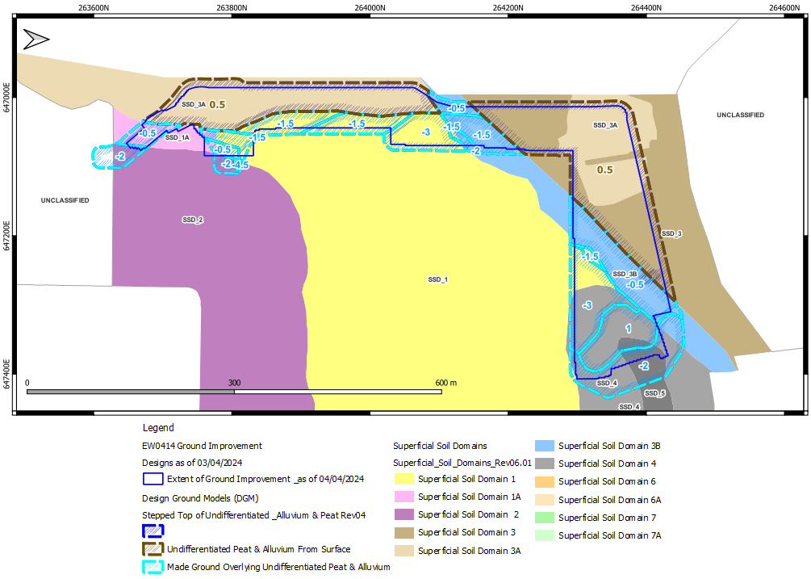
Figure 3-2 – Simplified EW0414-P_03 Top of Undifferentiated Alluvium & Peat Plan
The top of Crag Group (base of Undifferentiated Alluvium & Peat) has been locally stepped as a cautious estimate of (lower than) the TEGG GGM Rev C surface and critical proven points in local GI. The GGM surface (5213850-SNC-MR-XX-M3DM-G-000001 [3] [4]) is considered a best estimate. This stepping is presented in EGCS, EGLS, EW0414-P_04 Top of Crag Elevation Plan, Figure 3-4 and is summarised in Table 3-5.
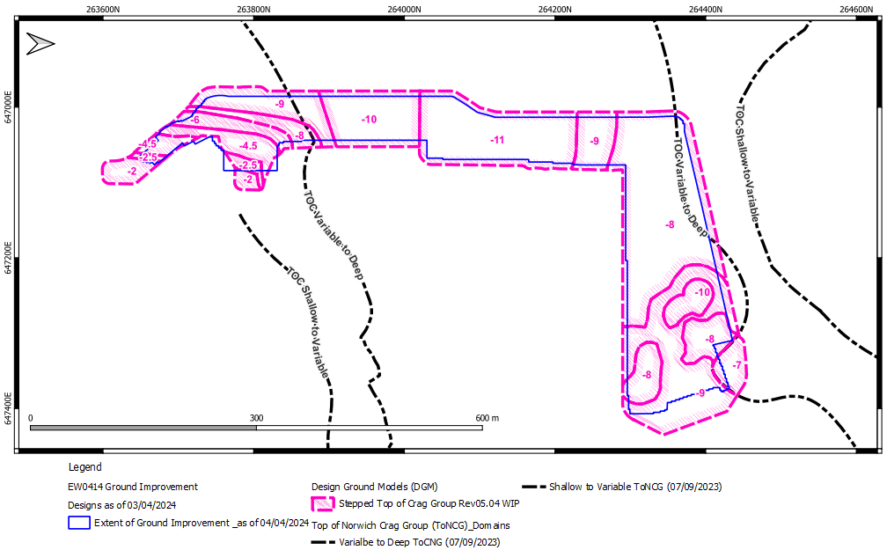
Figure 3-3 – Simplified EW0414-P_04 Top of Crag Group Plan
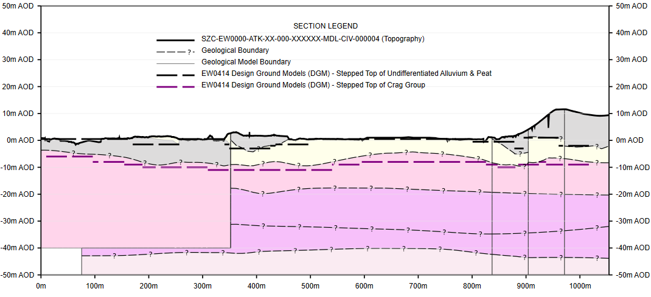
Figure 3-4 – Simplified EW0414-EGLS_01 Showing stepped top of Crag Group
Table 3-5 – Stepped top of Crag and Reference DGMs
Alignment | Top of NCG m AOD | Start Chainage | End Chainage
EW0414  Main  Alignment  EW0414  Main  Alignment | -2.5 | 0 | 12
 | -4.5 | 12 | 47
 | -6 | 47 | 63
 | -8 | 63 | 121
 | -9 | 121 | 155
 | -10 | 155 | 275
 | -11 | 275 | 507
 | -9 | 508 | 558
 | -8 | 558 | 817
 | -9 | 817 | 873
 | -8 | 873 | 951
 | -9 | 951 | 974
Ramp  Alignment | -8 | 0 | 3
 | -9 | 3 | 75
SZB Southern  Access  Road  Alignment | -2 | 0 | 53
 | -2.5 | 53 | 63
 | -4.5 | 63 | 101
 | -4.5 | 101 | 124
 | -6 | 124 | 161
 | -8 | 161 | 205
 | -6 | 205 | 223
 | -4.5 | 223 | 227
Notes:
- Chainage is set out in general arrangement drawings:
  - SZC-EW0414-ATK-XX-HSZ-01XXXX-DRW-CIV-000001,
  - SZC-EW0414-ATK-XX-HSZ-01XXXX-DRW-CIV-000002
  - SZC-EW0414-ATK-XX-HSZ-01XXXX-DRW-CIV-000003
  - SZC-EW0414-ATK-XX-HSZ-01XXXX-DRW-CIV-000004
  - SZC-EW0414-ATK-XX-HSZ-02XXXX-DRW-CIV-000001
  - SZC-EW0414-ATK-XX-HSZ-02XXXX-DRW-CIV-000002
  - SZC-EW0414-ATK-XX-HSZ-02XXXX-DRW-CIV-000003
  - SZC-EW0414-ATK-XX-HSZ-02XXXX-DRW-CIV-000004
  - SZC-EW0414-ATK-XX-HSZ-02XXXX-DRW-CIV-000005

Engineering Geological Plans and Sections
Engineering Geological Long Sections (EGLS) and Engineering Geological Cross Sections (EGCS) have been taken at locations to inform the understanding of the ground conditions for design (termed EGLS_# and EGCS_# where # is section number). The EGLS and EGCS are summarised in Table 3-6 and presented in Appendix B.
Table 3-6 – EW0412 DGM reference drawings
Drawing Reference | Drawing Title | Revision | Appendix  Reference
EW0412-P_01 | EW0414-P_01 Topography Plan | Rev05 | B.2
EW0412-P_02 | EW0414-P_02 Superficial Soil Domain Plan | Rev05 | B.2
EW0414-P_03 | EW0414-P_03 Top of Undifferentiated Alluvium & Peat Elevation Plan | Rev05 | B.2
EW0414-P_04 | EW0414-P_04 Top of Crag Elevation Plan | Rev05 | B.2
EW0414-P_05 | EW0414-P_05 Thickness of Superficial Deposits Isopach Plan | Rev05 | B.2
EW0414-EGLS_01 | EW0414-EGLS_01 – North and West Ground Improvement Engineering Geological Long Section | Rev05 | B.3
EW0414-EGLS_02 | EW0414-EGLS_02 - Southern Access Road Engineering Geological Long Section | Rev05 | B.3
EW0414-EGCS_01 | EW0414-EGCS_01 - EW0414-DGM_11 Engineering Geological Cross Section | Rev05 | B.3
EW0414-EGCS_02 | EW0414-EGCS_02 - EW0414-DGM_12 Engineering Geological Cross Section | Rev05 | B.3
EW0414-EGCS_03 | EW0414-EGCS_03 - EW0414-DGM_13 Engineering Geological Cross Section | Rev05 | B.3
EW0414-EGCS_04 | EW0414-EGCS_04 - EW0414-DGM_14 Engineering Geological Cross Section | Rev05 | B.3
EW0414-EGCS_05 | EW0414-EGCS_05 - EW0414-DGM_15 Engineering Geological Cross Section | Rev05 | B.3
EW0414-EGCS_06 | EW0414-EGCS_06 - EW0414-DGM_16 Engineering Geological Cross Section | Rev05 | B.3
EW0414-EGCS_07 | EW0414-EGCS_07 - EW0414-DGM_17 Engineering Geological Cross Section | Rev05 | 0

Design Ground Models
The DGMs are summarised in the following tables and rationale. For all following DGMs design groundwater levels presented separately, refer to Section 3.3.1.

Table 3-7 – EW0414-DGM_11 – South West Corner of MCA COW
Stratum | No. of  Points (top) | Top Level  (mAOD) |  | Bottom Level  (mAOD) |  | Top Level  (mAOD) | Bottom Level  (mAOD) | Thickness  (m)
 |  | Min. | Max. | Min. | Max. | Design | Design | Design
Undifferentiated Alluvium & Peat ^{[2]} | 3 | 0.48 | 0.52 | -7.18 | -1.09 | 0.50 (GL) | -4.50 to -9.00 | 5.00 to 9.50
Crag Group ^{[3]} | 2 | -2.92 | -7.18 | -43.51 |  | -4.50 to -9.00 | -43.51 | 38.01

Design Ground Model Rationale
[1] | Made Ground | Made Ground excluded to represent SSD_3A. Made Ground is anticipated to the East where the ground improvement interfaces with SSD_1A and SSD_2.
[2] | Alluvium & Peat | Alluvium & Peat anticipated from ground level (GL).  Alluvium & Peat is highly variable in this area and are therefore undifferentiated. Thickness is taken between design bottom of Made Ground and top of Crag Group.
[3] | Crag Group | The top of Crag Group is proven in SSSI-CPT05-EW at -7.18m AOD, -a range of -4.50 to -9.00m AOD is adopted stepping down to the west. It is noted that for the most cautious estimate, a design level of -9.00m AOD should be adopted as there is a low data density and therefore low certainty in this DGM.  Base of Crag Group is adopted from CHB 2009_10 south-east of the DGM at -43.51 m AOD.
[4] | Data Gaps | There are only 3 boreholes present within the DGM area of applicability.

Table 3-8 – EW0414-DGM_12A – Alluvium & Peat Overlying Deepest Crag (SSD_3A)
Stratum | No. of  Points (top | Top Level  (m AOD) |  | Bottom Level  (m AOD) |  | Top Level  (m AOD) | Bottom Level  (m AOD) | Thickness  (m)
 |  | Min. | Max. | Min. | Max. | Design | Design | Design
Undifferentiated Alluvium & Peat ^{[2]} | 0 | N/A^{[4]} | N/A^{[4]} | N/A^{[4]} | N/A^{[4]} | 0.50 (GL) | -11.00 | 11.50
Crag Group ^{[3]} | 0 | N/A^{[4]} | N/A^{[4]} | N/A^{[4]} |  | -11.00 | -42.48 | 31.48

Design Ground Model Rationale
[1] | Made Ground | Made Ground not anticipated within the SSSI in SSD_3A, variable Made Ground in anticipated north of the DGM in SSD_3B as proven by YG205.
[2] | Alluvium & Peat | Alluvium & Peat anticipated from ground level (GL).  Alluvium & Peat are highly variable in this area and are therefore undifferentiated. Thickness is taken between ground level and top of Crag Group.
[3] | Crag Group | The top of Crag varies greatly across the base of the paleo-erosion channel feature. The morphology of the base of the channel is shallowly undulating however there may be further incised channels up to 2 m below the typical channel base.  A design level of -11.00 m AOD is selected however local incised channels to -12.18 m AOD are anticipated (MPM 2009_10).  The bottom level of Crag Group is adopted from DCBH2019_8 at -42.48.
[4] | Data Gaps | There are no boreholes present within the DGM area of applicability, key levels are informed by MPM 2009_10 100 m north-east of the DGM.

Table 3-9 – EW0414-DGM_12B – Made Ground Overlying Deepest Crag (SSD_2)
Stratum | No. of  Points (top | Top Level  (m AOD) |  | Bottom Level  (m AOD) |  | Top Level  (m AOD) | Bottom Level  (m AOD) | Thickness  (m)
 |  | Min. | Max. | Min. | Max. | Design | Design | Design
Made Ground ^{[1]} | 9 | 1.51 | 2.79 | -4.83 | -2.86 | 2.00 (GL) | -1.5 to -3.00 | 3.50- to 5.00
Undifferentiated Alluvium & Peat ^{[2]} | 9 | -4.83 | -2.86 | -10.61 | -6.66 | -1.5 to -3.00 | -11.00 | 8.00 to 9.50
Crag Group ^{[3]} | 9 | -10.61 | -6.66 | -42.48 | -41.23 | -11.00 | -42.48 | 31.48

Design Ground Model Rationale
[1] | Made Ground | Made Ground is encountered from ground level (GL) in all boreholes. The base of Made Ground typically ranges from -2.86 to -4.83 m AOD (DSM CPT 2 and CBH 2009_6U respectively).  As Made Ground is variable across the DGM Are of Applicability the design level is stepped between -1.50 and -3.00 m AOD. Refer to geological plans and sections for local stepping.
[2] | Alluvium & Peat | Alluvium & Peat are highly variable in this area and are therefore undifferentiated. Thickness is taken between design bottom of Made Ground and top of Crag Group.
[3] | Crag Group | The top of Crag Group varies greatly across the base of the paleo-erosion channel feature. The morphology of the base of the channel is shallowly undulating however there may be further incised channels up to 2 m below the typical channel base.  A design level of -11.00 m AOD is selected however local incised channels to -12.18 m AOD are anticipated (MPM 2009_10).  The bottom level of Crag Group is adopted from DCBH2019_8 at -42.48 m AOD.

Table 3-10 – EW0414-DGM_13 – Alluvium & Peat Overlying Deepest Crag Group (SSD_3)
Stratum | No. of  Points (top | Top Level  (m AOD) |  | Bottom Level  (m AOD) |  | Top Level  (m AOD) | Bottom Level  (m AOD) | Thickness  (m)
 |  | Min. | Max. | Min. | Max. | Design | Design | Design
Undifferentiated Alluvium & Peat ^{[2]} | 3 | 0.53 | 0.7 | -7.57 | -7.41 | 0.5 (GL) | -11.00 | 11.50
Crag Group ^{[3]} | 2 | -7.57 | -7.41 | N/A | N/A | -11 | -41.28 | 30.28

Design Ground Model Rationale
[1] | Made Ground | Made Ground excluded in DGM to represent SSD_3A. SSD_3B to the south may contain variable thickness of Made Ground.
[2] | Alluvium & Peat | Alluvium & Peat is anticipated from ground level (GL) and is highly variable in this area and are therefore undifferentiated. Thickness is taken between ground level (GL) and design top of Crag Group.
[3] | Crag Group | The top of Crag Group varies greatly across the base of the paleo-erosion channel feature. The morphology of the base of the channel is shallowly undulating however there may be further incised channels up to 2 m below the typical channel base.  A design level of -11.00 m AOD is selected however local incised channels to -12.18 m AOD are anticipated (MPM 2009_10).  The bottom level of Crag Group is adopted from MPM 2009_10 at -41.28 m AOD 45 m south-east of the DGM.
[4] | Data Gaps | There are only 3 boreholes present within the DGM area of applicability, key levels are informed by MPM 2009_10 45 m south-east of the DGM.

Table 3-11 – EW0414-DGM_14A – North West Corner
Stratum | No. of  Points (top) | Top Level  (m AOD) |  | Bottom Level  (m AOD) |  | Top Level  (m AOD) | Bottom Level  (m AOD) | Thickness  (m)
 |  | Min. | Max. | Min. | Max. | Design | Design | Design
Undifferentiated Alluvium & Peat ^{[2]} | 1 | 1.36 | 1.36 | N/A | N/A | 0.50 (GL) | -8.00 | 8.50
Crag Group ^{[3]} | 0 | N/A | N/A | N/A | N/A | -8.00 | -41.28 | 33.28

Design Ground Model Rationale
[1] | Made Ground | Made Ground excluded in DGM to represent SSD_3 and SSD_3A. Adjacent SSD_3B may contain variable thickness of Made Ground.
[2] | Alluvium & Peat | Alluvium & Peat is anticipated from ground level (GL) and is highly variable in this area and are therefore undifferentiated. Thickness is taken between ground level (GL) and design top of Crag Group.
[3] | Crag Group | The top of Crag Group varies greatly across the base of the paleo-erosion channel feature. This DGM sits at the northern edge of the paleo-erosion channel feature with Crag Group shallowing to the north as represented by EW0414-DGM_14B.  A design level of -8.00 is selected as a cautious estimate of surrounding ground investigation (-7.43 m AOD in DSM CPT 5 10 m east of the DGM).  The bottom level of Crag Group is adopted from MPM 2009_10 at -41.28 m AOD.
[4] | Data Gaps | Low density of boreholes in this area.

Table 3-12 – EW0414-DGM_14B – North West Corner
Stratum | No. of  Points (top) | Top Level  (m AOD) |  | Bottom Level  (m AOD) |  | Top Level  (m AOD) | Bottom Level  (m AOD) | Thickness  (m)
 |  | Min. | Max. | Min. | Max. | Design | Design | Design
Undifferentiated Alluvium & Peat ^{[2]} | 4 | 1.31 | 2.88 | -5.99 | -4.02 | 0.50 (GL) | -8.00 | 8.50
Crag Group ^{[3]} | 4 | -5.99 | -4.02 | N/A | N/A | -8.00 | -41.28 | 35.28

Design Ground Model Rationale
[1] | Made Ground | Made Ground excluded in DGM to represent SSD_3 and SSD_3A.
[2] | Alluvium & Peat | Alluvium & Peat is anticipated from ground level (GL) and is highly variable in this area and are therefore undifferentiated. Thickness is taken between ground level (GL) and design top of Crag Group.
[3] | Crag Group | The top of Crag Group varies greatly across the base of the paleo-erosion channel feature. This DGM sits at the northern edge of the paleo-erosion channel feature with Crag becoming deeper to the south as represented by EW0414-DGM_14A.  A design level of -8.00 is selected as a cautious estimate of GI within the DGM area of applicability due to the low density of the top of Crag Group observed in CPT results.  The bottom level of Crag Group is adopted from MPM 2009_10 at -41.28 m AOD.
[4] | Data Gaps | Low density of boreholes in this area.

Table 3-13 – EW0414-DGM_15 – Deep Crag Group adjacent to the Northern Mound
Stratum | No. of  Points (top) | Top Level  (m AOD) |  | Bottom Level  (m AOD) |  | Top Level  (m AOD) | Bottom Level  (m AOD) | Thickness  (m)
 |  | Min. | Max. | Min. | Max. | Design | Design | Design
Made Ground ^{[1]} | 35 | 0.5 | 2.45 | -5.82 | 1.45 | Absent or 2.00 | Absent or - 0.50 to - 3.00 | Absent to 5.00
Undifferentiated Alluvium & Peat ^{[2]} | 36 | -5.82 | 1.45 | -10.16 | -4.3 | 0.50 to - 3.00 | -8.00 to -10.00 | 5.00 to 10.50
Crag Group ^{[3]} | 32 | -10.16 | -5.29 | -43.76 | -40.71 | -8.00 to -10.00 | -43.76 | 33.76 to 35.76

Design Ground Model Rationale
[1] | Made Ground | As Made Ground is variable or absent across the DGM the design bottom level is stepped. Where present the base of Made Ground ranges from -1.00 to -4.00 m AOD. Refer to geological plans EW0414-P_02, EGCS and EGLS for stepping.
[2] | Alluvium & Peat | Alluvium & Peat are highly variable in this area and are therefore undifferentiated.  Thickness is taken between top of Crag Group and ground level where made ground is absent (GL, 0.5 m AOD) or design bottom of Made Ground where Made Ground is present.
[3] | Crag Group | As top of Crag Group is variable across the DGM, the design level is stepped between -10.00 and -8.00 m AOD. Refer to geological plans EW0414-P_04, EGCS and EGLS for stepping.  The bottom level of Crag Group is adopted from YB3 at -43.76 m AOD.

Table 3-14 – EW0414-DGM_16 – Variable and Deep Crag Group underlying the Northern Mound
Stratum | No. of  Points (top) | Top Level  (m AOD) |  | Bottom Level  (m AOD) |  | Top Level  (m AOD) | Bottom Level  (m AOD) | Thickness  (m)
 |  | Min. | Max. | Min. | Max. | Design | Design | Design
Made Ground ^{[1]} | 19 | 3.52 | 16.1 | -3.08 | 1.86 | Up to 12.00 (GL) ^{[4]} | 1.00 to -4.00 | 11.00 to 16.00
Undifferentiated Alluvium & Peat ^{[2]} | 12 | -3.08 | 1.86 | -7.66 | -5.74 | 1.00 to -4.00 | -9.00 to -7.00 | 3.00 to 10.00
Crag Group ^{[3]} | 6 | -7.66 | -5.74 | NA | NA | -9.00 to -7.00 | -43.76 | 34.76 to 36.76

Design Ground Model Rationale
[1] | Made Ground | Made Ground associated with the Northern Mound is anticipated from ground level (GL) and present in all boreholes in SSD_4 and SSD_5.  As Made Ground is variable across the DGM, the design bottom level is stepped between 1.00 to -4.00 m AOD. Refer to geological plans EW0414-P_02, EGCS and EGLS for local stepping.
[2] | Alluvium & Peat | Alluvium & Peat are highly variable in this area and are therefore undifferentiated.  Thickness is taken between design bottom of Made Ground and top of Crag Group. YG206 has thickest peat profile however excluded due to topographical inconsistency.
[3] | Crag Group | As top of Crag Group is variable or absent across the DGM, the design level is stepped between -9.00 and -7.00 m AOD. Refer to geological plans EW0414-P_04, EGCS and EGLS for local stepping.  The bottom level of Crag Group is adopted from YB3 at -43.76 m AOD.
[4] | Ground Level | Ground level taken from the top of the Northern Mound, this the design level may change due to works within the EW0415 Early Works and Profiling package.

Table 3-15 – EW0414-DGM_17A – Southern Access Road SSD_1
Stratum | No. of Points (top) | Top level (m AOD) | Bottom level (m AOD) | Thickness (m)
 |  | Design | Design | Design
Made Ground ^{[1]} | 0 | 6.00 (GL) | -2.00^{[4]} (Data Gap) | 8.00
Crag Group ^{[3]} | 0 | -2.00^{[4]} (Data Gap) | -43.51 | 45.51

Design Ground Model Rationale
[1] | Made Ground | Made Ground is anticipated from ground level (GL) due to construction of Sizewell B and landscaping of the MCA.  There is no nearby GI proving the base of Made Ground. GI in the wider area shows that it is highly variable. Thickness is taken between ground level (GL) and design top of Crag Group.
[2] | Alluvium & Peat | DGM is characterised by an absence of Alluvium & Peat although there is no local GI proving its absence.
[3] | Crag Group | In the area of the Southern Access Road top of crag is anticipated to dip to the west. There is a low density of nearby GI proving the top of Crag Group.  Top of Crag is cautious inferred at -2 m AOD from regional GI including digitized historical boreholes.
[4] | Data Gaps | Low density of boreholes in this area. Several historical boreholes located in area and used for reference. This data gap results in significant uncertainty in the ground model at this location.

Table 3-16 – EW0414-DGM_17B – Southern Access Road SSD_1A
Stratum | No. of Points (top) | Top level (m AOD) | Bottom level (m AOD) | Thickness (m)
 |  | Design | Design | Design
Made Ground ^{[1]} | 0 | 4.00 (GL) | -0.5^{[4]} (Data Gap) | 4.50
Undifferentiated Alluvium & Peat ^{[2]} | 0 | -0.5^{[4]} (Data Gap) | -2.50 to -4.50^{[4]} (Data Gap) | 2.00 to 4.00
Crag Group | 1 | -2.50 to -4.50^{[4]} (Data Gap) | -43.51 | -39.01

Design Ground Model Rationale
[1] | Made Ground | Made Ground is anticipated from ground level (GL) due to construction of Sizewell B and landscaping of the MCA.  There is no nearby GI proving the base of Made Ground. GI in the wider area shows that it is highly variable.
[2] | Alluvium & Peat | Alluvium & Peat are highly variable in this area and are therefore undifferentiated.  Undifferentiated Alluvium & Peat is anticipated underlying Made Ground. There is no nearby GI proving its thickness or extent. GI in the wider area shows that it is highly variable.
[3] | Crag Group | In the area of the Southern Access Road top of Crag Group is anticipated to dip to the west. There is a low density of nearby GI proving the top of Crag Group.  A 1968 borehole (1968_330) indicates a density change in sands at -3.71 m AOD. This is inferred as the top of Crag Group and a cautious estimate of top of Crag Group of -4.5 m AOD is adopted.  Base of Crag Group is adopted from CBH 2009_10 at 43.51 70 m north-east of the DGM.
[4] | Data Gaps | Low density of boreholes in this area. Several historical boreholes located in area and used for reference. This data gap results in significant uncertainty in the ground model at this location.

Table 3-17 – EW0414-DGM_17C – Southern Access Road SSD_3A
Stratum | No. of Points (top) | Top level (m AOD) | Bottom level (m AOD) | Thickness (m)
 |  | Design | Design | Design
Undifferentiated Alluvium & Peat ^{[2]} | 0 | 0.5 (GL) | -4.50 to -9.00 ^{[4]} (Data Gap) | 5.00 to 9.50
Crag Group ^{[3]} | 1 | -4.50^{[4]} (Data Gap) | -43.51 | -39.01

Design Ground Model Rationale
[1] | Made Ground | No Made Ground is anticipated within SSD_3A / the SSSI.
[2] | Alluvium & Peat | Alluvium & Peat are highly variable in this area and are therefore undifferentiated.  Undifferentiated Alluvium & Peat is anticipated from ground level and thickness taken between ground level (GL) and top of Crag Group.
[3] | Crag Group | In the area of the Southern Access Road top of Crag Group is anticipated to dip to the west. There is a low density of nearby GI proving the top of Crag Group.  A 1968 borehole (1968_330) 10 m south-west of alignment that has not been digitized indicates a density change in sands at -4.71 m AOD. Deeper top of Crag Group is proven in south west of the DGM in SSSI-CPT05-EW at -7.18m AOD. A range of -4.50 to -9.00m AOD is adopted stepping down to the west. It is noted that for the most cautious estimate, a design level of -9.00m AOD should be adopted as there is a low data density and therefore low certainty in this DGM.  Base of Crag Group is adopted from CBH 2009_10 at 43.51 70 m north-east of the DGM.
[4] | Data Gaps | Low density of boreholes in this area. Several historical boreholes located in area and used for reference. This data gap results in significant uncertainty in the ground model at this location.

Geological Information, Data, Plans and Sections

Geotechnical Information / Data
The following sources of information have been used in developing the ground models and parameters.
Table B-1 Available geotechnical reports
Document/Drawing Title | Document/Drawing Reference | Revision | Revision Date
EPR UK – Sizewell C – Phase 2 Ground Investigation Report | SZC - DIXXXX - XX - 000 - RET – 200010 | D | 13/05/2022
Geotechnical Design Report (Ground Conditions and Geotechnical Parameters) | SZC-EW0400-ATK-XX-000-XXXXXX-REP-CIV-000002 | P04 | 12/07/2023
Notes:
- Factual Contractor GI Reports are described in the GIR and GDR above.
Table B-2 Available geotechnical drawings
Document/Drawing Title | Document/Drawing Reference | Revision | Revision Date
Exploratory Hole Location Plan- MCA | SZC-EW0400-ATK-XX-000-XXXXXX-DRW-CIV-000001 | 02 | 17/08/22
Thickness of Made Ground Isopaches - MCA | SZC-EW0400-ATK-XX-000-XXXXXX-DRW-CIV-000003 | 03 | 07/07/23
Thickness of Superficial Deposits Isopaches - MC | SZC-EW0400-ATK-XX-000-XXXXXX-DRW-CIV-000004 | 03 | 07/07/23
Crag Deposits Elevation Contours - MCA | SZC-EW0400-ATK-XX-000-XXXXXX-DRW-CIV-000005 | 03 | 07/07/23
Engineering Geological Section MCA01-MCA01 | SZC-EW0400-ATK-XX-000-XXXXXX-DRW-CIV-000008 | 02 | 16/08/22
Engineering Geological Section MCA05-MCA05 | SZC-EW0400-ATK-XX-000-XXXXXX-DRW-CIV-000012 | 02 | 17/08/22
Engineering Geological Section MCA06-MCA06 | SZC-EW0400-ATK-XX-000-XXXXXX-DRW-CIV-000013 | 02 | 16/08/22
Engineering Geological Section MCA07-MCA07 | SZC-EW0400-ATK-XX-000-XXXXXX-DRW-CIV-000014 | 02 | 16/08/22
Engineering Geological Section MCA08-MCA08 | SZC-EW0400-ATK-XX-000-XXXXXX-DRW-CIV-000015 | 02 | 16/08/22
Table B-3 Available geotechnical models
Model Title | Model Reference | Revision | Revision Date
Geotechnical Design Ground Model | 5213850-SNC-MR-XX-M3DM-G-000001 | P1 | 18/04/2023
Existing Ground Surface | SZC-EW0000-ATK-XX-000-XXXXXX-MDL-CIV-000004 | P02 | 07/11/2022
TEGG GGM Top of Undifferentiated Recent Deposits Elevation Surface | 5213850-SNC-MR-XX-M3DM-G-000009 | P01 | 15/02/2023
TEGG GGM Top of Norwich Crag Group (C1) Elevation Surface | 5213850-SNC-MR-XX-M3DM-G-000005 | P01 | 15/02/2023
TEGG GGM Top of Red Crag Group Thorpeness Member (C2) Elevation Surface | 5213850-SNC-MR-XX-M3DM-G-000007 | P01 | 15/02/2023
TEGG GGM Top of Red Crag Group Sizewell Member (C3) Elevation Surface | 5213850-SNC-MR-XX-M3DM-G-000006 | P01 | 15/02/2023
TEGG GGM Top of Thames Group (Harwich) Elevation Surface | 5213850-SNC-MR-XX-M3DM-G-000008 | P01 | 15/02/2023
Table B-4 Available geotechnical databases
Database Ref. | Database Name / Description | Revision | Revision Date
OpenGround Cloud Atkins SNCL | Sizewell C Enabling Works | N/A | N/A
SZC_Database_SBP | Self-boring pressuremeter database | GIR Rev C | 30/09/2021
SZC_database_boreholes_c | Borehole database | GIR Rev C | 30/09/2021
SZC_database_lab-tests_h | Laboratory testing database | GIR Rev C | 30/09/2021
SCZ_database_CPT | CPT testing database | GIR Rev C | 30/09/2021
SZC_database_CTT-RCT_a | Cyclic triaxial tests and resonant column testing database | GIR Rev C | 30/09/2021
SZC_database_hydrogeology_a | Hydrogeology database | GIR Rev C | 30/09/2021
SZC_database_mohr_circles_c | Direct shear & triaxial interp. database | GIR Rev C | 30/09/2021
SZC_database_MPM_d | Ménard pressuremeter testing database | GIR Rev C | 30/09/2021
SZC_database_PSD | Particle size distribution analysis database | GIR ev C | 30/09/2021
SZC_Database_SBP | elf-boring pressuremeter testing database | GIR Rev C | 30/09/2021
SZC_database_SPT_b | SPT testing database | GIR Rev C | 30/09/2021
SZC_database_Vs-Vp_a | compression and shear wave velocity database | GIR Rev C | 30/09/2021
Table B-5 Data digitized
Document/Drawing Title | No. of Exploratory Points^{[1]} | Year
GEORGE WIMPEY. 1968. Report S/6517 “Proposed Sizewell ‘B’ power station, Suffolk – Report on site investigation” | 3 | 1968
Notes:
[1] Rotary core boreholes 326, 329 and 330 from GEORGE WIMPEY. 1968. Report S/6517 “Proposed Sizewell ‘B’ power station, Suffolk – Report on site investigation” [5] digitized to inform top of Crag Group levels in the area surrounding the Southern Access
Table B-6 Data excluded
Document/Drawing Title | No. of Exploratory Points | Year
LE GRAND SUTCLIFF. 1957. Report 882 “Site investigation at the Warren Sizewell (site 4) | 6 | 1957
L.G. MOUCHEL. 1958. Report 4/63/SJB/20607 “Investigation of nuclear power station sites in Suffolk” | Unknown | 1958
LE GRAND ADSCO. 1959. Report 1105 “Site investigation at Sizewell” | 9 | 1959
SOIL MECHANICS. 1960. Report 3315/1 “Site investigation for proposed nuclear power station at Sizewell – Onshore” | 83 | 1960
GEORGE WIMPEY. 1968. Report S/6517 “Proposed Sizewell ‘B’ power station, Suffolk – Report on site investigation” | 39 | 1968
SOIL MECHANICS. 1970. Report 5609/1 "Dewatering report" | 2 | 1970
Foundation Engineering. 1976. Report CF669/1385 “Sizewell ‘B’ power station – Factual Report on Onshore Site Investigation” | 13 | 1976
CEGB. 1976. Report “DC/MTS/SM355 “Sizewell ‘B’ power station – Contractor’s plant area and access road – Site investigation” | 34 | 1976
SOIL MECHANICS. 1976. Report 6729 “Sizewell ‘B’ nuclear power station – Dewatering investigation 1976” | 2 | 1976
Soil Mechanics. 1981. Report 7713/S17392 “Site investigation (1980) for Sizewell ‘B’ power station – Sizewell, Suffolk | 30 | 1981
SOIL MECHANICS. 1989. Report 7441 "Site investigation at Sizewell C" | 152 | 1989
SOIL MECHANICS. 1995. Report 7875/A “Sizewell C power station – Site investigation” | 0 | 1995
SOIL MECHANICS. 2011. Report A0012-10“Onshore investigations phase 1 for Sizewell site – Factual report on ground investigation” | 1 | 2011

Geological Plans

EW0414-P_01 Topography Plan

EW0414-P_02 Superficial Soil Domain Plan

EW0414-P_03 Top of Undifferentiated Alluvium & Peat Elevation Plan

EW0414-P_04 Top of Crag Elevation Plan

EW0414-P_05 Thickness of Superficial Deposits Isopach Plan

Geological Sections

EW0414-EGLS_01 – North and West Ground Improvement Engineering Geological Long Section

EW0414-EGLS_02 - Southern Access Road Engineering Geological Long Section

EW0414-EGCS_01 - EW0414-DGM_11 Engineering Geological Cross Section

EW0414-EGCS_02 - EW0414-DGM_12 Engineering Geological Cross Section

EW0414-EGCS_03 - EW0414-DGM_13 Engineering Geological Cross Section

EW0414-EGCS_04 - EW0414-DGM_14 Engineering Geological Cross Section

EW0414-EGCS_05 - EW0414-DGM_15 Engineering Geological Cross Section

EW0414-EGCS_06 - EW0414-DGM_16 Engineering Geological Cross Section

EW0414-EGCS_07 - EW0414-DGM_17 Engineering Geological Cross Section

